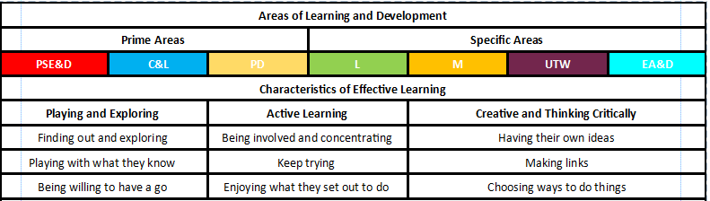
Early Years Staff Evaluation
Feedback for Leader:

How could this activity be improved?

Observation carried out by:
Date: Camp:
Leader being observed:

Any health and safety issues involved in this activity?

Are the children focused, engaged and interested in the activity?

Was the activity well planned, prepared and delivered?

Activity:

Number of children:
Observer Signature: Leader’s Signature:

